title: ‘Pre-programme Assignment 1’ author: “celestin” date: “MARS 15 2021” output: word_document: toc: yes html_document: highlight: zenburn theme: flatly toc: yes toc_float: yes ___

## Practice using Markdown

## Pandoc

# Task 1: Short biography written using markdown

# my biograpy

my is zongo celestin. i came from burkina faso, my twon city is koudougou. i got my CEP degre in 2008 in my village call gogo. after that i came to kougougou to continue my studies.i got my BEPC degre in 2015 and my BAC in koudougou at Lycee schorge.after that i enroll my selft at BIT where i study couputer science.  
* in 2018 semester 1&2 * in 2019 semester 3&4 * in 2019 semester 5&6 # Task 2: gapminder country comparison

glimpse(gapminder)

## Rows: 1,704  
## Columns: 6  
## $ country <fct> "Afghanistan", "Afghanistan", "Afghanistan", "Afghanistan", ~  
## $ continent <fct> Asia, Asia, Asia, Asia, Asia, Asia, Asia, Asia, Asia, Asia, ~  
## $ year <int> 1952, 1957, 1962, 1967, 1972, 1977, 1982, 1987, 1992, 1997, ~  
## $ lifeExp <dbl> 28.801, 30.332, 31.997, 34.020, 36.088, 38.438, 39.854, 40.8~  
## $ pop <int> 8425333, 9240934, 10267083, 11537966, 13079460, 14880372, 12~  
## $ gdpPercap <dbl> 779.4453, 820.8530, 853.1007, 836.1971, 739.9811, 786.1134, ~

head(gapminder, 20) # look at the first 20 rows of the dataframe

## # A tibble: 20 x 6  
## country continent year lifeExp pop gdpPercap  
## <fct> <fct> <int> <dbl> <int> <dbl>  
## 1 Afghanistan Asia 1952 28.8 8425333 779.  
## 2 Afghanistan Asia 1957 30.3 9240934 821.  
## 3 Afghanistan Asia 1962 32.0 10267083 853.  
## 4 Afghanistan Asia 1967 34.0 11537966 836.  
## 5 Afghanistan Asia 1972 36.1 13079460 740.  
## 6 Afghanistan Asia 1977 38.4 14880372 786.  
## 7 Afghanistan Asia 1982 39.9 12881816 978.  
## 8 Afghanistan Asia 1987 40.8 13867957 852.  
## 9 Afghanistan Asia 1992 41.7 16317921 649.  
## 10 Afghanistan Asia 1997 41.8 22227415 635.  
## 11 Afghanistan Asia 2002 42.1 25268405 727.  
## 12 Afghanistan Asia 2007 43.8 31889923 975.  
## 13 Albania Europe 1952 55.2 1282697 1601.  
## 14 Albania Europe 1957 59.3 1476505 1942.  
## 15 Albania Europe 1962 64.8 1728137 2313.  
## 16 Albania Europe 1967 66.2 1984060 2760.  
## 17 Albania Europe 1972 67.7 2263554 3313.  
## 18 Albania Europe 1977 68.9 2509048 3533.  
## 19 Albania Europe 1982 70.4 2780097 3631.  
## 20 Albania Europe 1987 72 3075321 3739.

Your task is to produce two graphs of how life expectancy has changed over the years for the country and the continent you come from.

I have created the country_data and continent_data with the code below.

country_data <- gapminder %>%   
 filter(country == "Burkina Faso") # just choosing Greece, as this is where I come from  
  
continent_data <- gapminder %>%   
 filter(continent == "africa")

First, create a plot of life expectancy over time for the single country you chose. You should use geom_point() to see the actual data points and geom_smooth(se = FALSE) to plot the underlying trendlines. You need to remove the comments **#** from the lines below for your code to run.

plot1 <- ggplot(data =country_data, mapping = aes(x = year, y = lifeExp))+  
 geom_point() +  
 geom_smooth(se = FALSE)+  
 NULL   
 plot1

## `geom_smooth()` using method = 'loess' and formula 'y ~ x'

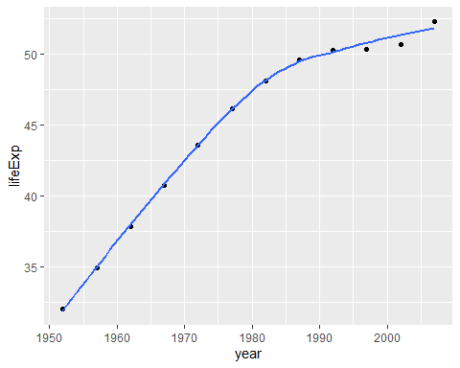

Next we need to add a title. Create a new plot, or extend plot1, using the labs() function to add an informative title to the plot.

plot1<- ggplot(data = country_data, mapping = aes(x = year, y = lifeExp))+  
 geom_point() +  
 geom_smooth(se = FALSE) +  
 labs(title = "lifeExp in Burkina Faso ",  
 x = "year ",  
 y = "lifeExpentancy ") +  
 NULL  
  
  
 print(plot1)

## `geom_smooth()` using method = 'loess' and formula 'y ~ x'

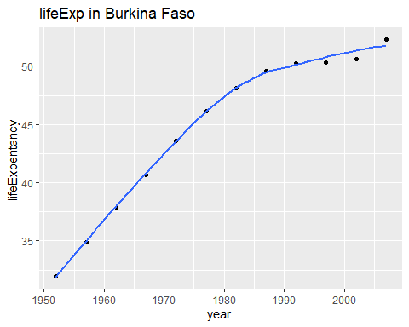

Secondly, produce a plot for all countries in the *continent* you come from. (Hint: map the country variable to the colour aesthetic).

ggplot(data =continent_data , mapping = aes(x =year , y = lifeExp , colour=country ))+  
 geom_point() +   
 geom_smooth(se = FALSE) +  
 NULL

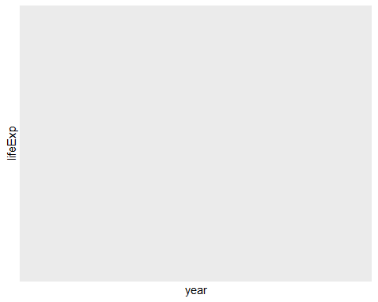

ggplot(data = gapminder , mapping = aes(x =year , y = lifeExp , colour=country ))+  
 geom_point() +   
 geom_smooth(se = FALSE) +  
 facet_wrap(~continent) +  
 theme(legend.position="none") + #remove all legends  
 NULL

## `geom_smooth()` using method = 'loess' and formula 'y ~ x'

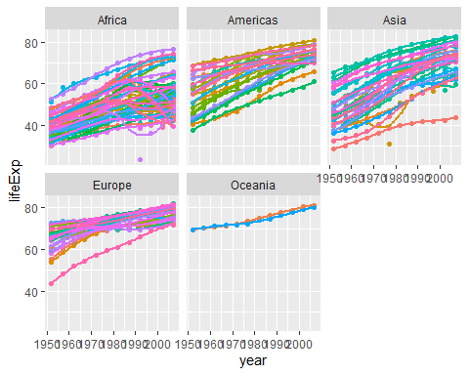

Given these trends, what can you say about life expectancy since 1952? Again, don’t just say what’s happening in the graph. Tell some sort of story and speculate about the differences in the patterns.

Type your answer after this blockquote.

# Task 3: Brexit voting

We will have a quick look at the results of the 2016 Brexit vote in the UK. First we read the data using read_csv() and have a quick glimpse at the data

brexit_results <- read_csv(here::here("Data","brexit_results.csv"))  
  
glimpse(brexit_results)

## Rows: 632  
## Columns: 11  
## $ Seat <chr> "Aldershot", "Aldridge-Brownhills", "Altrincham and Sale W~  
## $ con_2015 <dbl> 50.592, 52.050, 52.994, 43.979, 60.788, 22.418, 52.454, 22~  
## $ lab_2015 <dbl> 18.333, 22.369, 26.686, 34.781, 11.197, 41.022, 18.441, 49~  
## $ ld_2015 <dbl> 8.824, 3.367, 8.383, 2.975, 7.192, 14.828, 5.984, 2.423, 1~  
## $ ukip_2015 <dbl> 17.867, 19.624, 8.011, 15.887, 14.438, 21.409, 18.821, 21.~  
## $ leave_share <dbl> 57.89777, 67.79635, 38.58780, 65.29912, 49.70111, 70.47289~  
## $ born_in_uk <dbl> 83.10464, 96.12207, 90.48566, 97.30437, 93.33793, 96.96214~  
## $ male <dbl> 49.89896, 48.92951, 48.90621, 49.21657, 48.00189, 49.17185~  
## $ unemployed <dbl> 3.637000, 4.553607, 3.039963, 4.261173, 2.468100, 4.742731~  
## $ degree <dbl> 13.870661, 9.974114, 28.600135, 9.336294, 18.775591, 6.085~  
## $ age_18to24 <dbl> 9.406093, 7.325850, 6.437453, 7.747801, 5.734730, 8.209863~

The data comes from [Elliott Morris](https://www.thecrosstab.com/), who cleaned it and made it available through his [DataCamp class on analysing election and polling data in R](https://www.datacamp.com/courses/analyzing-election-and-polling-data-in-r).

Our main outcome variable (or y) is leave_share, which is the percent of votes cast in favour of Brexit, or leaving the EU. Each row is a UK [parliament constituency](https://en.wikipedia.org/wiki/United_Kingdom_Parliament_constituencies).

To get a sense of the spread of the data, plot a histogram and a density plot of the leave share in all constituencies.

ggplot(brexit_results, aes(x = leave_share)) +  
 geom_histogram(binwidth = 2.5)

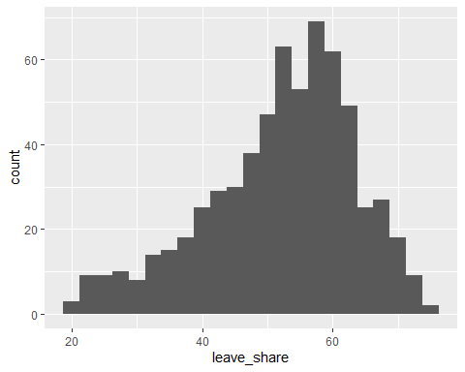

ggplot(brexit_results, aes(x = leave_share)) +  
 geom_density()

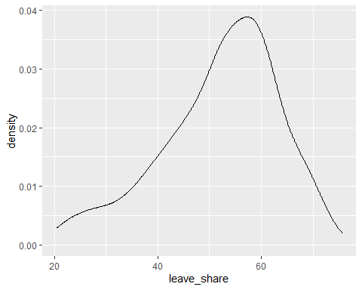

One common explanation for the Brexit outcome was fear of immigration and opposition to the EU’s more open border policy. We can check the relationship (or correlation) between the proportion of native born residents (born_in_uk) in a constituency and its leave_share. To do this, let us get the correlation between the two variables

brexit_results %>%   
 select(leave_share, born_in_uk) %>%   
 cor()

## leave_share born_in_uk  
## leave_share 1.0000000 0.4934295  
## born_in_uk 0.4934295 1.0000000

The correlation is almost 0.5, which shows that the two variables are positively correlated.

We can also create a scatterplot between these two variables using geom_point. We also add the best fit line, using geom_smooth(method = "lm").

ggplot(brexit_results, aes(x = born_in_uk, y = leave_share)) +  
 geom_point(alpha=0.3) +  
 geom_smooth(method = "lm") +  
 theme_bw() +  
 NULL

## `geom_smooth()` using formula 'y ~ x'

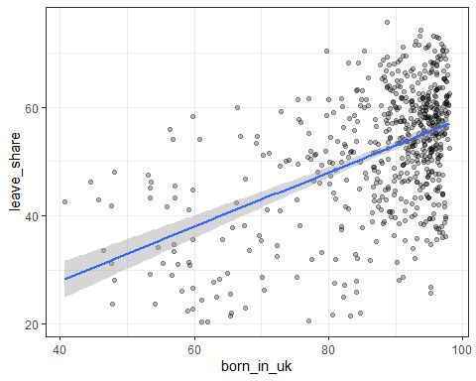

You have the code for the plots, I would like you to revisit all of them and use the labs() function to add an informative title, subtitle, and axes titles to all plots.

What can you say about the relationship shown above? Again, don’t just say what’s happening in the graph. Tell some sort of story and speculate about the differences in the patterns. s > Type your answer after, and outside, this blockquote.

# Submit the assignment

Knit the completed R Markdown file as ah HTML or Word document (use the “Knit” button at the top of the script editor window) and upload it to Canvas.

## Details

If you want to, please answer the following

* Who did you collaborate with: TYPE NAMES HERE
* Approximately how much time did you spend on this problem set: ANSWER HERE
* What, if anything, gave you the most trouble: ANSWER HERE